Phase 3 – High Fidelity Prototyping

Series Tracker

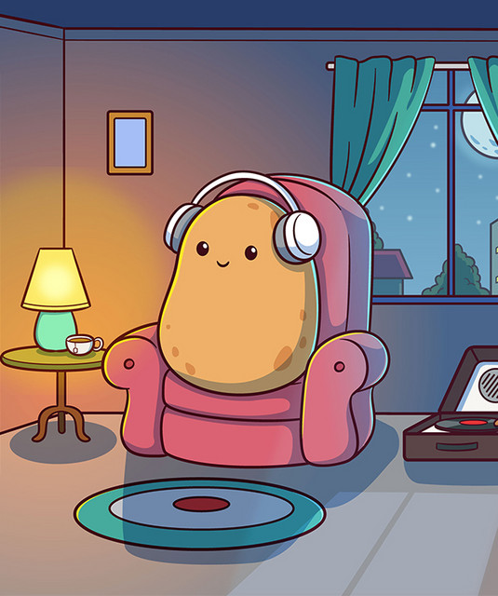

[Couch Potatoes]

Ambelal, S u21439321

Moshokoa, IJ u21785742

Modise, ZM u21508322

Siphuma, AT u21556416

Email address for feedback: u21785742@tuks.co.za

| Part 1 [15] | | Part 2 [10] | Part 3 [30] | | | |  |
| --- | --- | --- | --- | --- | --- | --- | --- |
| Revised wireframes  [5x2] | Final wireframe  [5] | Aesthetics  [10] | Design decisions (revised wireframes)  [5x2] | Analysis and design decisions (final)  [10] | Aesthetics design decisions  [5] | Navigation flow  [5] | Total  [55] |
|  |  |  |  |  |  |  |  |
|  |  |

# Report

**Question 2**

**Wireframe 1**

The phase 2 login and sign up and login page only had the option to sign up using email. In the revised wireframes alternative login and sign up options were added.

A simple tagline explaining the app’s purpose was added to the splash page.

We moved the search bar from the bottom of the home page to the top of the home page.

**Wireframe 2**

The welcome page that users found unnecessary was removed from the app flow.

We added a splash page, just like the one we had in wireframe one to welcome users.

We changed the placement of the “currently watching" section from the profile page to the home page.

We added a clearer call to action on the login page by replacing “I’m new here” with “Create an account”.

**Question 3**

**Wireframe 1**

**Search bar placement:** The Users found that the search bar in the home page of wireframe 1 was awkwardly placed therefore - The search bar was moved to the top of the page for better visibility and clarity of purpose. This should enhance user experience as it allows easier access to search functionality, making it more effective then it was before.

**Alternative login methods:** Users suggested adding an alternative method for login in so **-** Login via Google, Facebook and Apple was added which should increase convenience for users - this also allows the app to be as efficient as possible since users don't need to come up with a new username and password but just use one that is already readily available to them.

**Simple tagline:** Users suggested that the app should have a clear meaning as to exactly what it does on the Splash page. It explains the purpose of the app to improve user understanding of the app’s functionality and benefits thus increasing the User’s Learnability.

**Wireframe 2**

**Splash screen:** It was added to indicate the current app and provide a simple description of the app ensuring that the user quickly understands what the app's purpose is which results in user memorability.

**Welcome page removal:** removing this page that users found unnecessary should reduce distraction and let users focus on essential content. This provides a good utility for users and decreases redundancy.

**“Currently watching” section placement:** this section was moved to the home page for a more intuitive layout that should improve user engagement. This design aligns with standard streaming platform layouts, which increases external consistency - decreasing the learning burden.

**Clearer call-to-action:** the “Create an account” statement increases clarity and user navigation compared to “I’m new here” making it easier to learn and memorise.

**Question 4**

Users generally had positive feedback regarding the revisions made in both wireframes. Stakeholders must have felt reassured and pleased with the revisions made to the wireframes based on the positive feedback received. The improvements implemented addressed key user concerns and aligned with stakeholders' goals of creating a user-friendly and engaging app interface.

The concerns of stakeholders had less to do with the design, features and navigation of the app and more to do with spacing of certain content on a page and the visual appeal of the app. We were quickly able to make the necessary changes to the wireframes.

**How the decisions resulted in the final wireframe**

We asked stakeholders to choose their favourite features in either wireframe as a part of the feedback in order to create the final wireframe. This was done by merging the most preferred elements from each wireframe, ensuring that the end product incorporates the most valued aspects of both wireframes. The features with the highest votes were included in the final wireframe. If a feature had an equal number of votes for either wireframe, we merged aspects from both wireframes. For example, the community pages features are derived from both revised wireframes.

**Question 5**

We chose to explore different aesthetic decisions using the homepage of the final wireframe.

**Icons:**

There is a huge variety of icons available so we were able to create completely different combinations of icons. The first experiment features icons that are outlined, which provides a clean and minimalist look while still maintaining visual clarity. This decision was made to ensure that the icons are easily recognizable and do not overwhelm the page with excessive visual elements.

The second experiment featured icons with a fill, offering a more vibrant and visually striking aesthetic compared to outlined icons. Filled icons provide a solid and bold appearance, allowing them to command attention and stand out prominently on the page.

The third experiment features a combination of outlined and filled icons, which introduces a sense of inconsistency to the interface. This decision was made to explore the visual impact of mixing different icon styles, but it resulted in a lack of visual coherence and unity.

**Pictures**

For the pictures, we decided to showcase non-copyright images of the different series that are available for streaming. There are 2 different kinds of visual representations of pictures which are the series cover art and when the show is playing, it shows a cut scene of the current episode. This makes it clear for the user to see what they can watch and how far and which scene they stopped watching at.

**Fonts:**

We chose three different fonts for each experiment and repeated the experiment three times over. In the first experiment we used Sans Serif fonts which are more rounded fonts that give a casual and simple feel to the app. The second experiment we used Serif fonts that have sharper tones with pointed corners which formalised the app's appearance and made it more harsh looking. Lastly for the third experiment we used display fonts with thicker strokes and a bolder look which gave the app character and definition.

**Colour scheme:**

For our colour scheme we experimented with 11 different colour combinations - this helped us visualize what we want our app to look like in the long run - We made 4 in dark mode with dark yet simple colours to make them look minimalistic (this is for when the user wants to switch to dark mode) and we made 4 in light mode - again we were leaning more towards the minimalistic and simple look for the app. The other 2 were used to test whether our app would look good with different colour backgrounds. In each artboard we used 1 to 3 colours - to make it simple yet aesthetic .

**Buttons:**

For the buttons, we have chosen 3 different kinds, all visible on the picture's art board as part of the illustrations. The first button features edged edges and image containers, designed to enhance visual appeal and user engagement by providing clear visual cues and easy access to associated images, addressing accessibility. The second button combines edged and rounded edges, creating an aesthetically pleasing blend that balances modern design with user-friendly interaction, catering to users who appreciate a mix of sharp and smooth aesthetics while also focusing on touch-friendly design for ease of use on mobile devices. Lastly, the third button type shows smooth rounded edges for both the button and image containers, promoting a soft and inviting user experience, ideal for users seeking a gentle and cohesive interface that prioritizes visual consistency and a harmonious design language.

**Question 6**

**Logical Navigation FlowChart:**

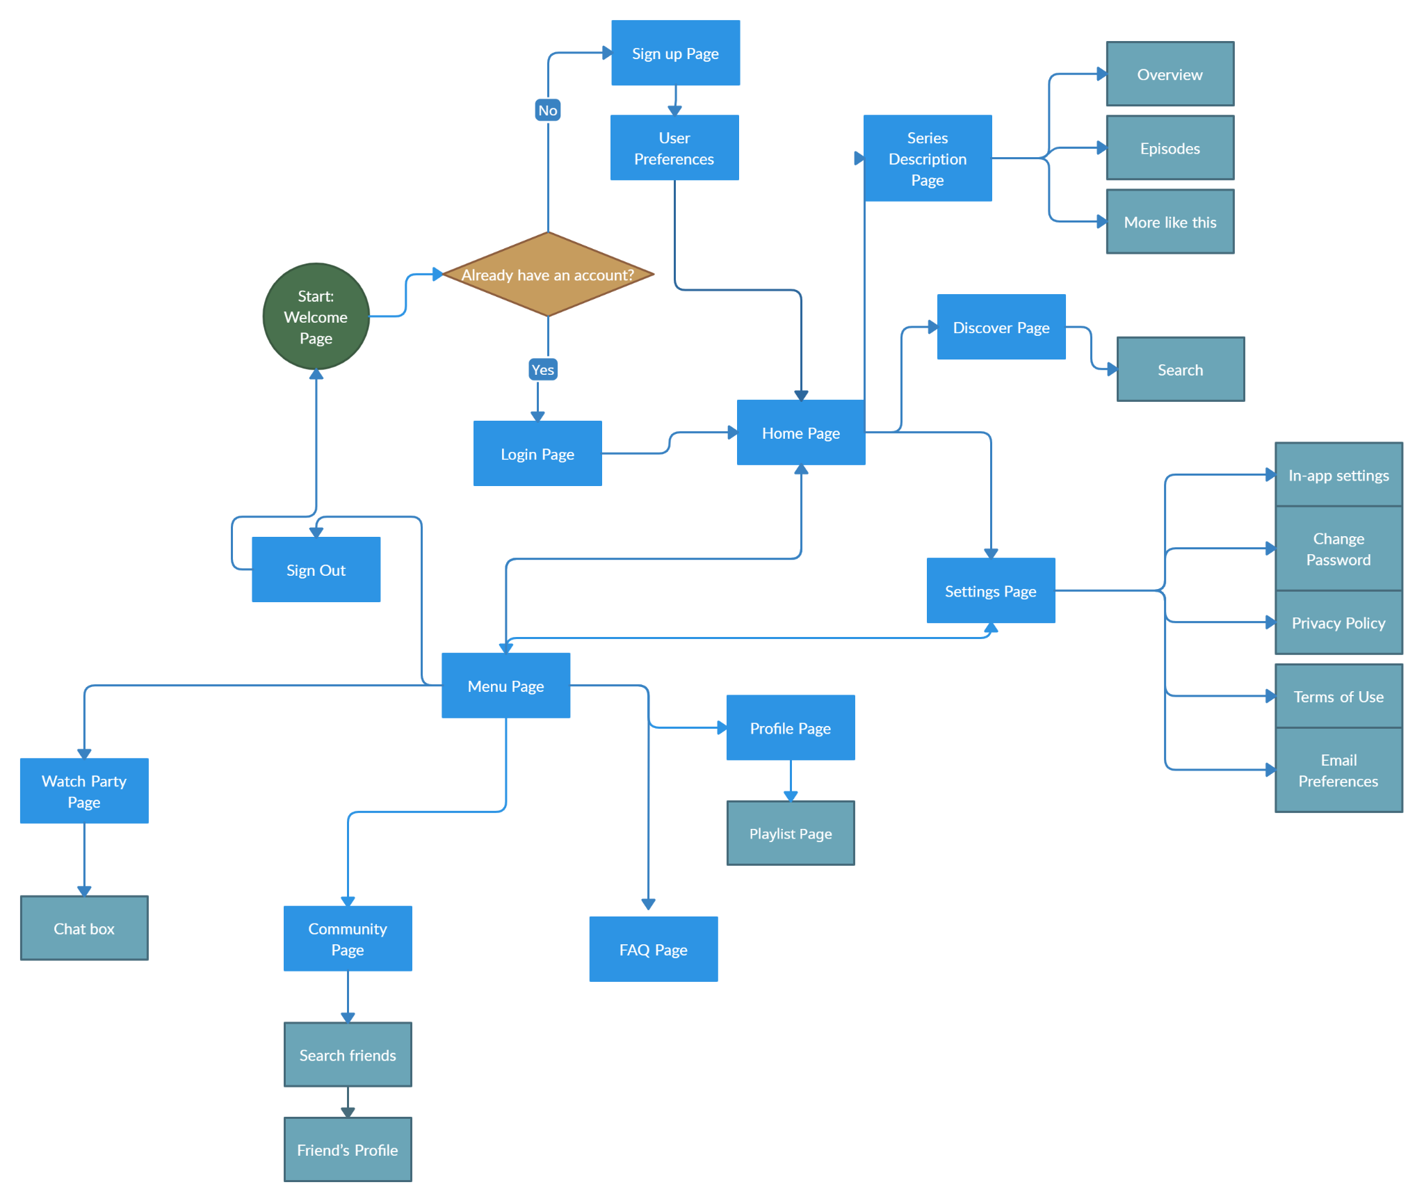

**Logical flow: Detailed Description:**

1. Start at the Welcome Page
   1. If you already have an account:
      1. Go to Login screen
         1. After logging in, you will be taken to the home page
   2. If you do not have an account:
      1. Go to Sign up page
         1. After signing up, you are taken to the User Preference page to pick the genres and series you prefer.
2. Menu Page:
   1. Search Bar which navigates to the Discover page.
   2. Home - redirects you to the home page
   3. Profile - to take you to your profile page
   4. Settings - redirects you to the settings page
   5. Community - redirects you to the community page
   6. Watch Party page for any of the series you are currently watching
   7. FAQ - all the frequently asked questions for our app
3. On the Home page:
   1. Menu button → navigation bar that can take you to any of the other pages in our app
   2. Currently watching shows which are shows that you have started and have a time stamp of where you left off the last time and a haven’t started list which shows the series recommended based on your previously watched.
   3. Discover takes you to the search page
      1. Search bar - navigates to the search page where you can search for shows
         1. The results show the top results, recommended and playlists the show is in.
            1. Have an option to add a show to your play
            2. Can access a playlist which takes you to the playlist page
   4. Shows takes you to the playlist page where you have saved things to watch
      1. Has the search history which shows the recent shows you’ve searched
      2. Recommended for you - has all the shows recommended for you based on the shows you've watched
      3. Trending - which shows all the current trending shows
   5. Settings page takes you to the settings that you can adjust
   6. Browse More Shows takes you to the discover page
4. Series Description shows you the details of a particular series
   1. Menu button → navigation bar that can take you to any of the other pages in our app
   2. Overview → genre, brief description and other detailed information about the series
      1. Add to Watchlist → adds the series to your playlist of things you would like to watch
   3. Episodes → shows the episodes for the series and how long each episode is.
   4. More like this → suggests similar series to the one you are currently viewing.
5. Profile Page:
   1. Shows statistics of how long you've spent time watching shows and on which days.
   2. Has all the playlists you've created/added to your profile
      1. Clicking on a playlist takes you to the Playlist page.
6. Watch Party Page:
   1. Watch Party Setup → enter nickname and choose platform to watch on
   2. Pick a Series to watch
   3. Watch series and use chat box to chat to friends in thee watch party
7. Settings Page:
   1. My Account settings → change personal details
      1. Change Password
      2. Private Policy
      3. Terms of Use
      4. Email Preferences
   2. In-app settings → switch between light and dark themes.
8. Community Page
   1. View all the series your community is currently watching and their reviews on the series
   2. Be able to interact by liking their review
   3. Has a search bar on top
      1. Can search new users or friends
         1. Navigate to their profile

**Feedback Screenshots:**

We used a poll on whatsapp to efficiently decide which pages were the best in our app between Wireframe 1 and Wireframe 2.

Here are the results:  
